Introduction
Welcome to your favorite day of the week which is programming day🎉. In this lab manual, we shall work together to learn and implement new programming concepts.

Let's do some coding.

Introduction
By this week, you have learned how to write a program that contains functions, loops, arrays and conditional structures. In this class, we will learn permanently store the data into the computer and how to decompose difficult problems into small sets of easy problems and then solve them easily.

Consider that we want to develop a game that the characters as Tanks where we have a player tank and three enemy tanks and the enemy dies after collision with the fire generated by the player and vise versa while the score of the game increases.
Lets execute our idea of the game one step at a time.

Consider this mini game with the above mentioned features for better understanding.


Lets code it out !
Step 01: Print Maze and Characters
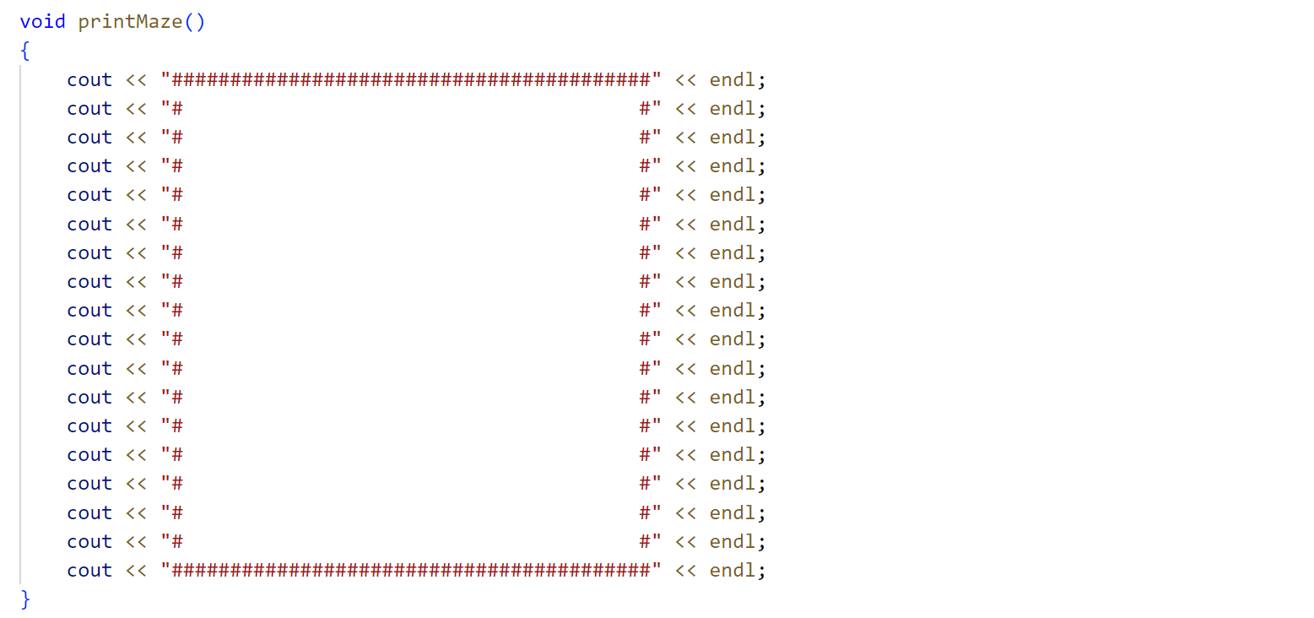
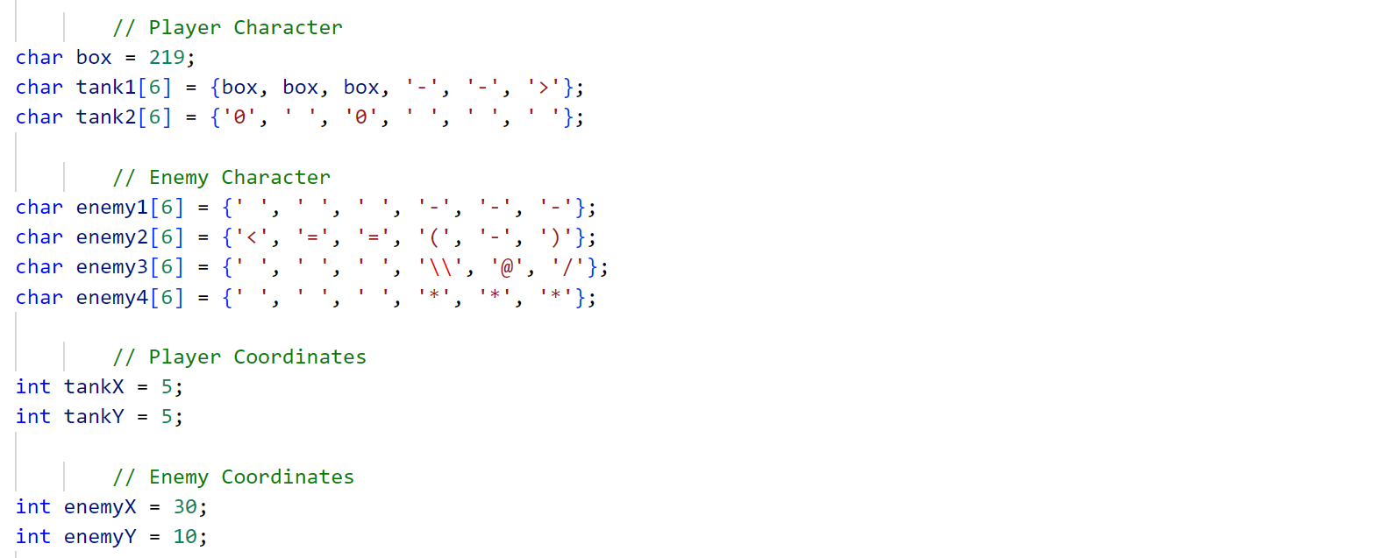
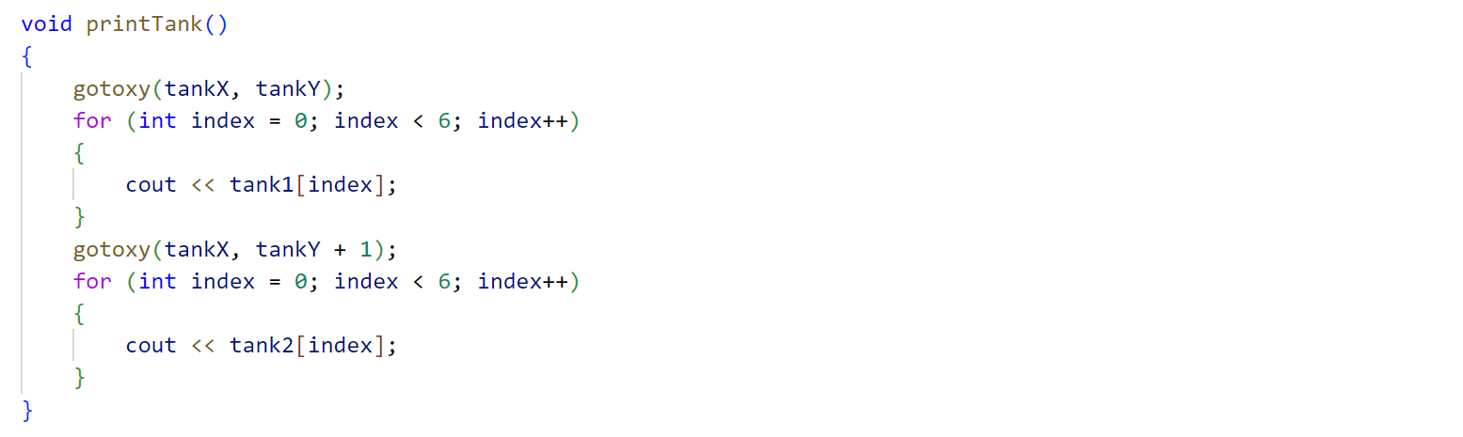
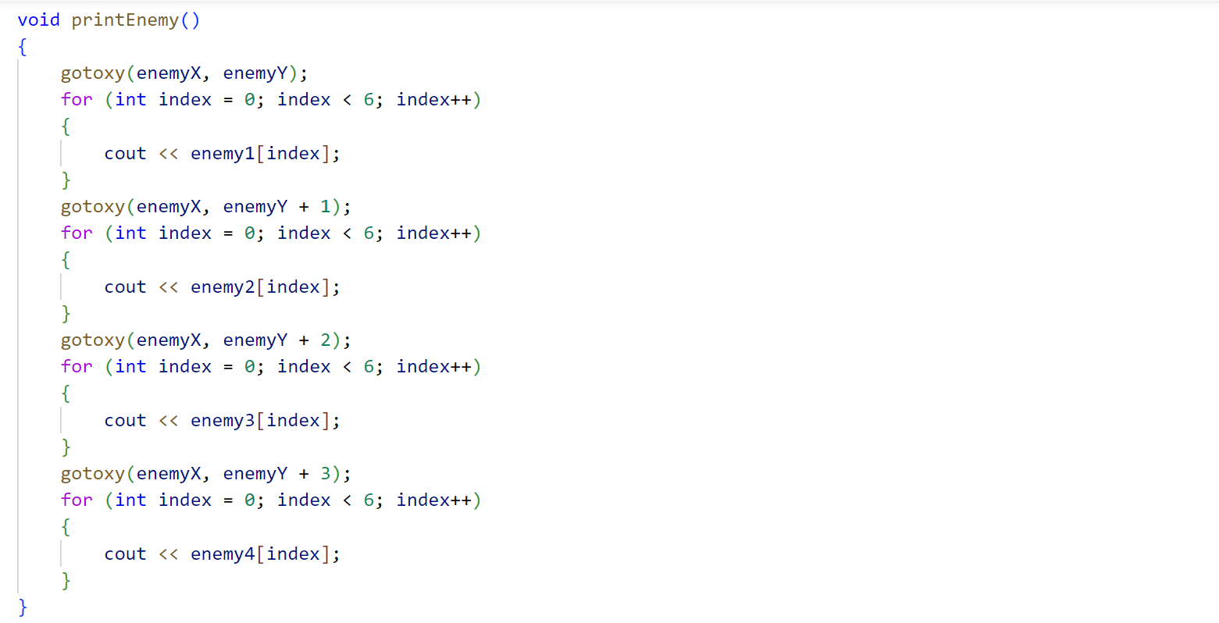
Step 02: Character Movement
- Player Movement
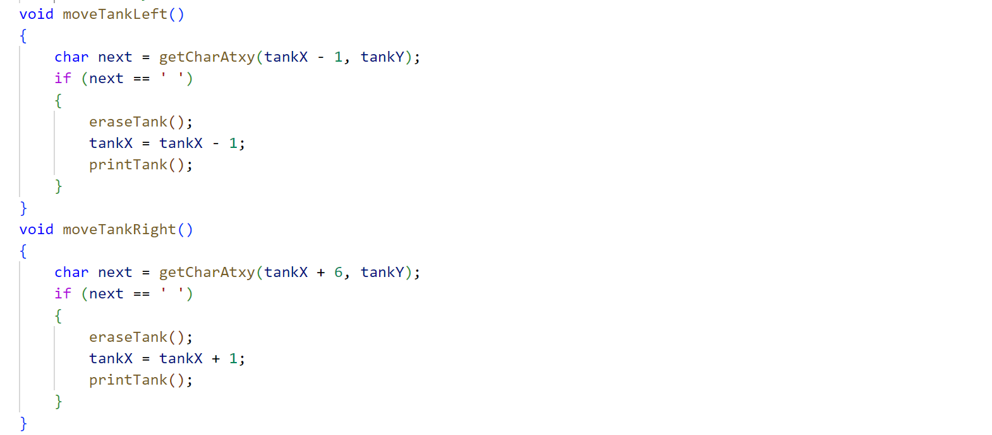
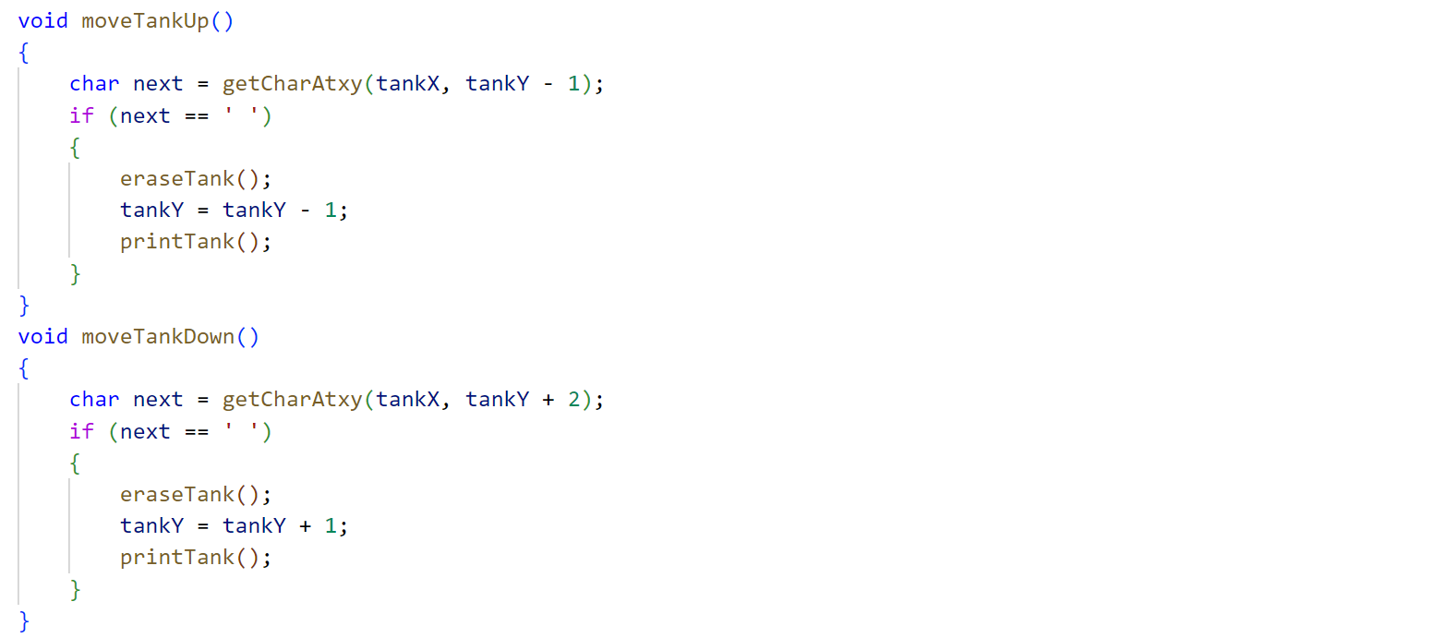
- Enemy Movement
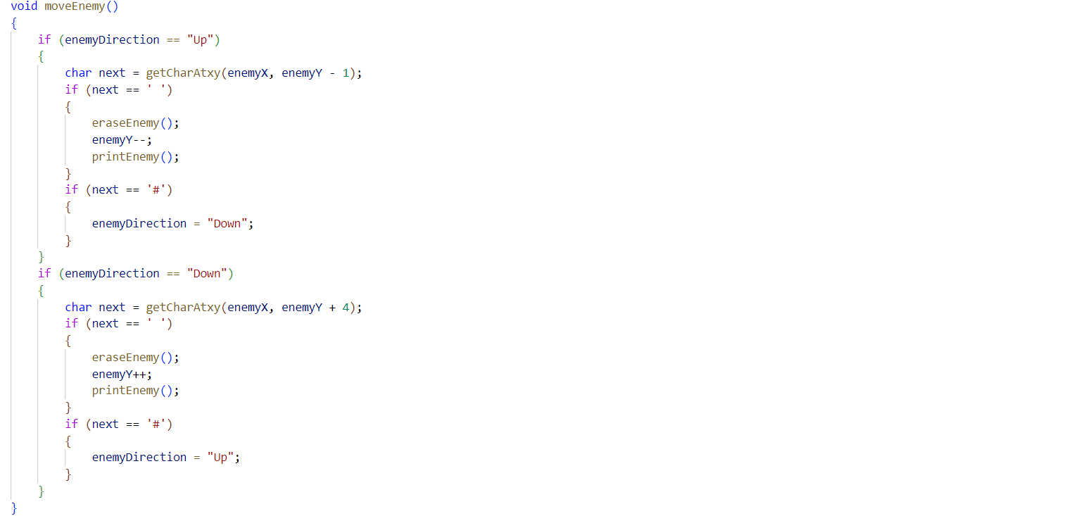
- Supporting Functions
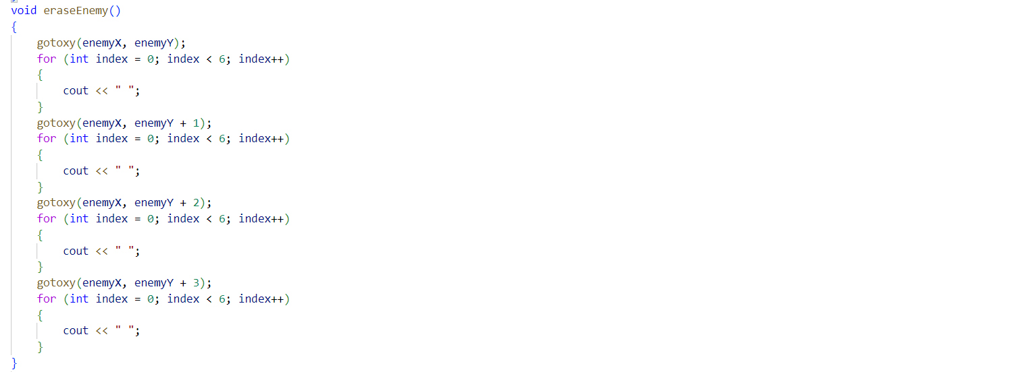
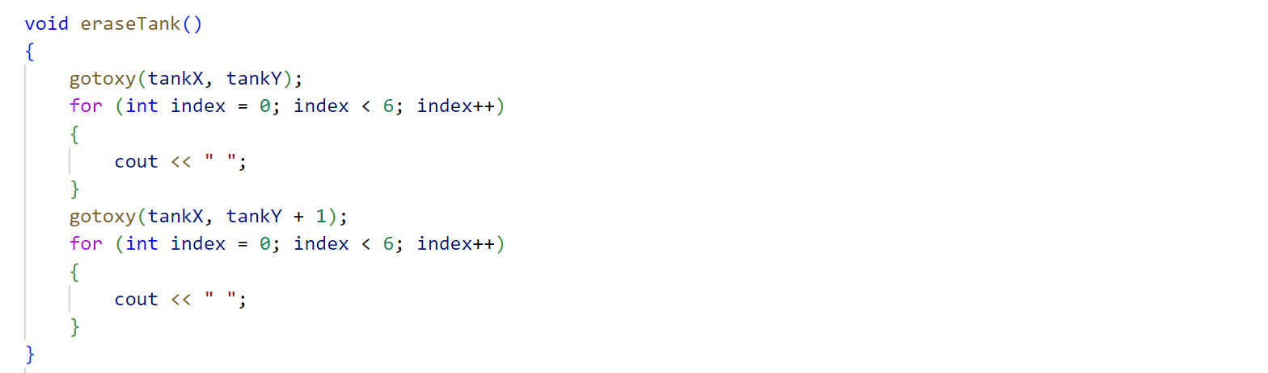
Step 03: Firing/Shooting
- Global Arrays and Variable
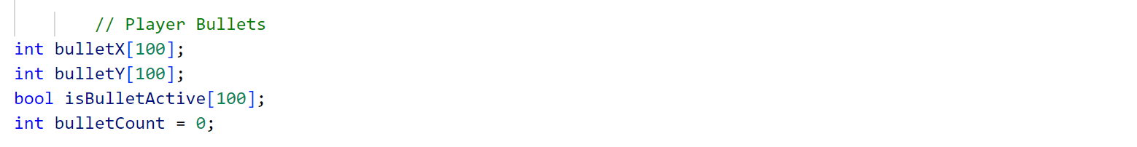
- Generate Bullet
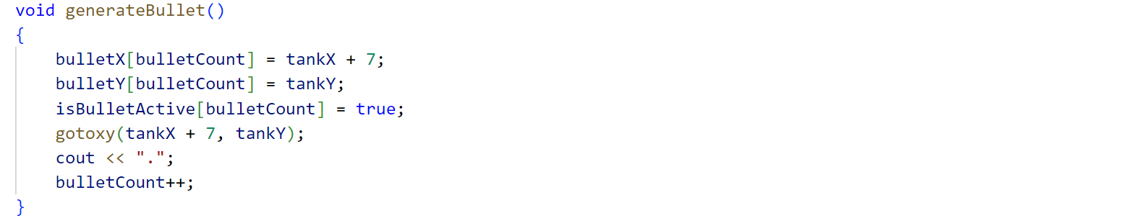
- Move Bullet
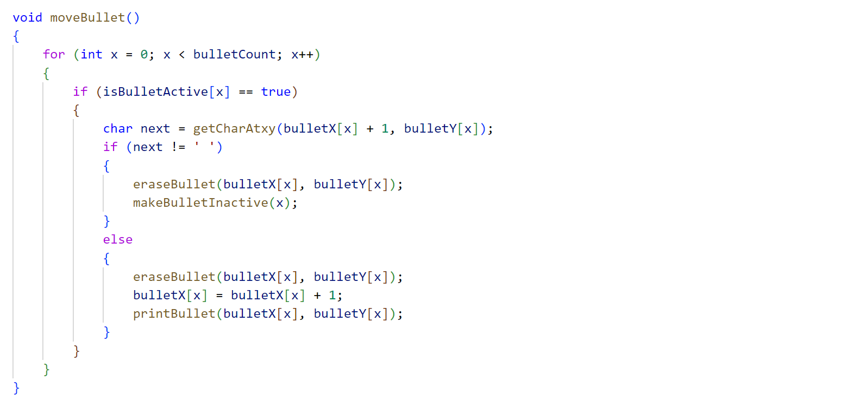
- Supporting Functions
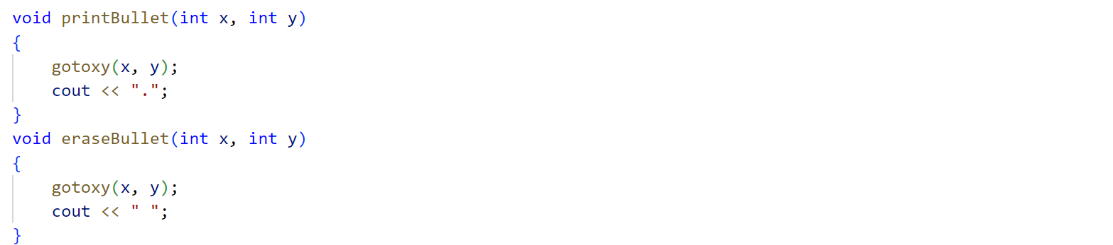
Step 04: Collision Detection
- Collision With Enemy
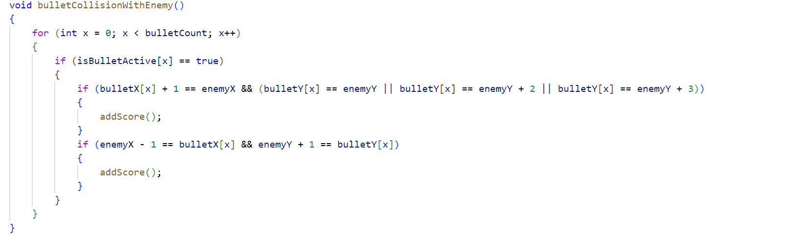
- Reward/Score
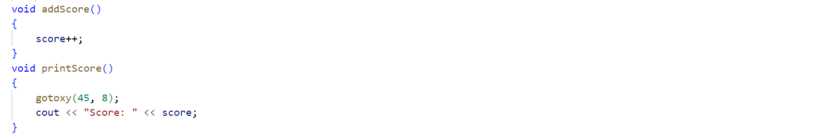
- Supporting Functions
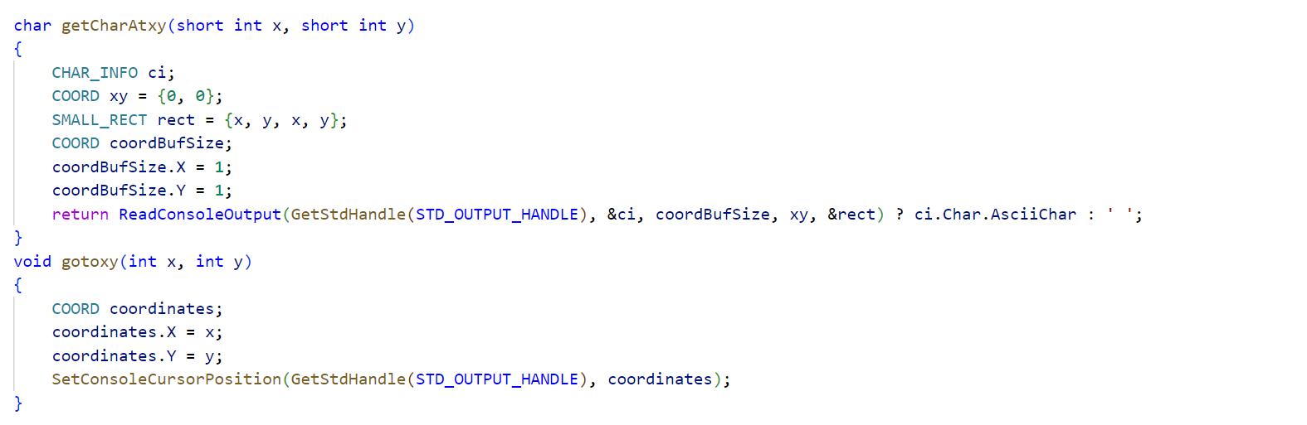
- Main Function
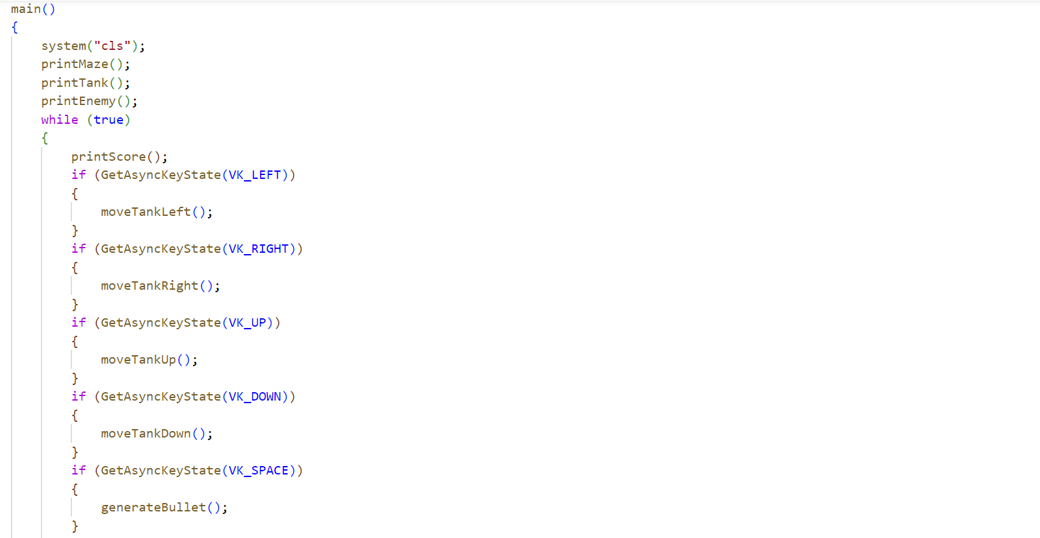
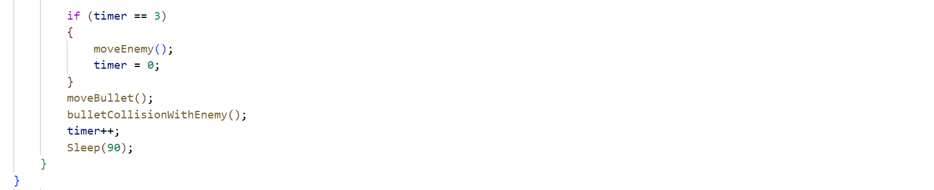

Good Luck and Best Wishes !!
Happy Coding ahead :)

